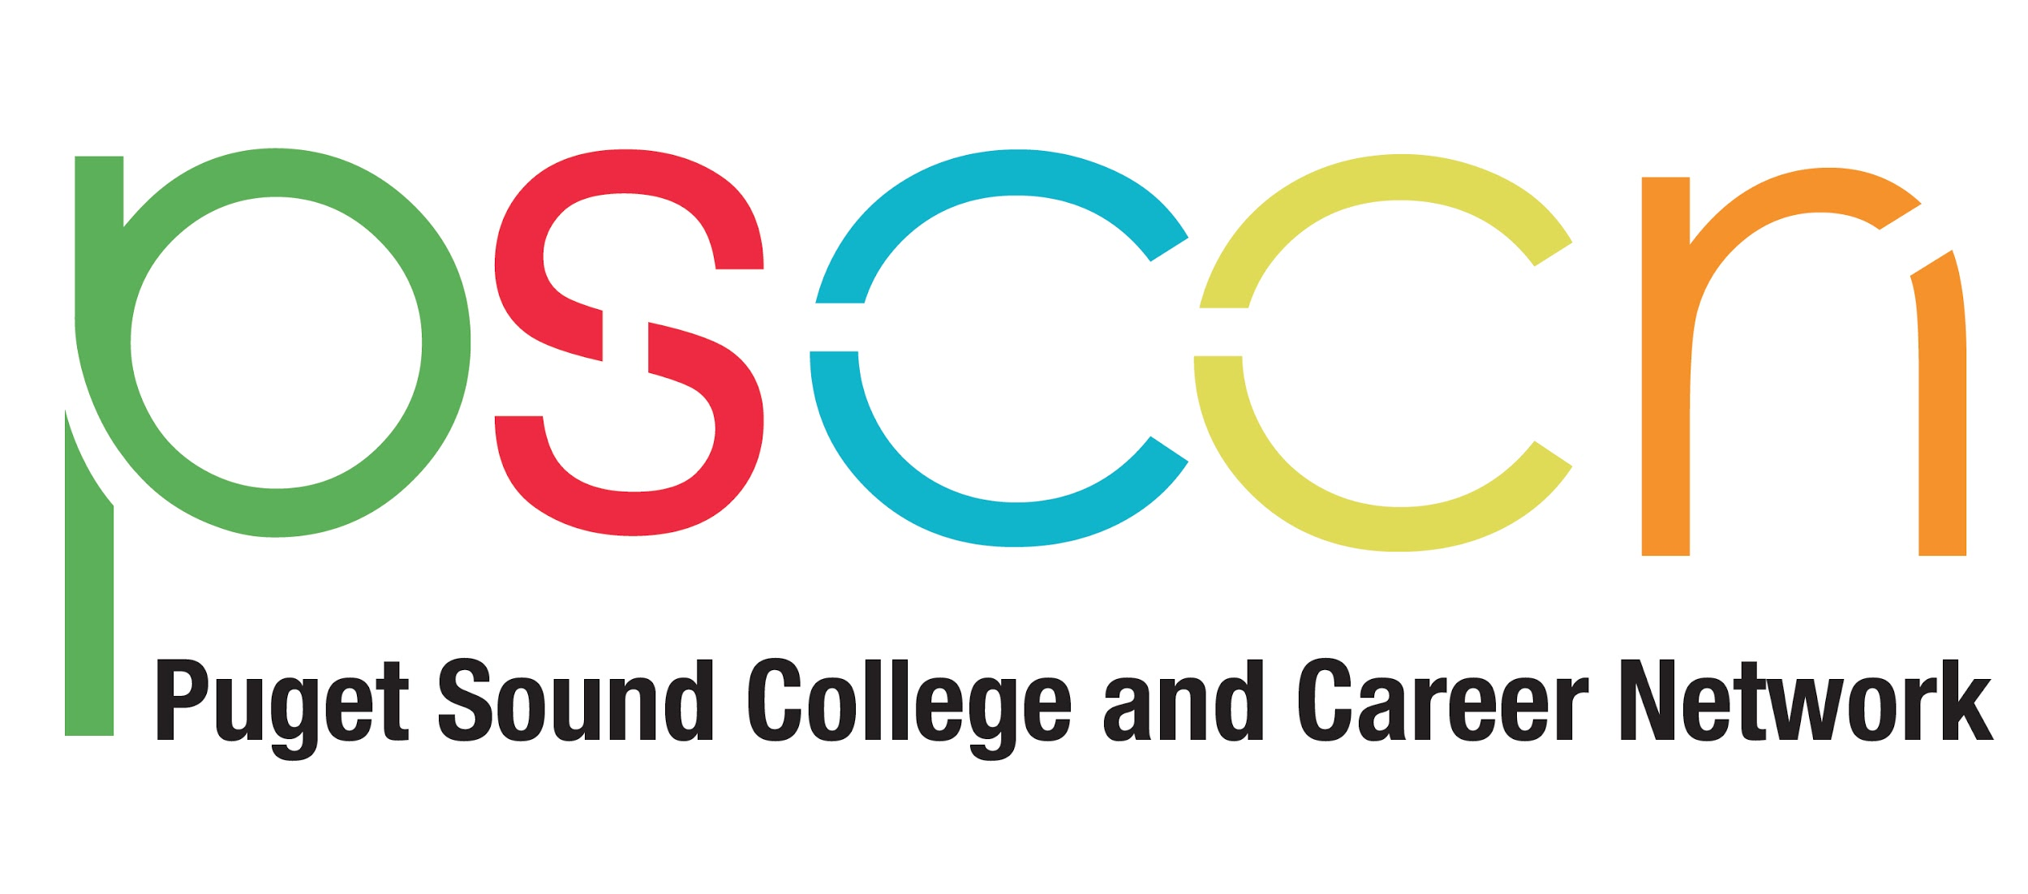

Spanish Radio Campaign Summary

In 2018, PSCCN broadcasted a weekly Spanish radio program on Radio Luz-AM Radio 1680 sharing information and taking calls from the public on a range of financial aid and college knowledge topics to model and share family messages about college access. Priority topics include financial aid, myth-busting, and where families can turn for resources in their community. Through this campaign, PSCCN sought to increase Spanish-speaking communities’ awareness of college knowledge and college financial aid.

Each episode was 10-15 minutes and included interviews with school staff, community leaders, and responding to questions from listeners.

Weekly content was based on the College Knowledge materials and followed the yearly graded level timelines. For example, in July 2019, we covered “Increasing Financial Aid Completion: Understanding the Why, with a focus on 9th and 10 graders that included All About High School, Benefits of Going To College, Types of Colleges, Requirements To Graduate And Apply To College and Ways To Pay For College.

Guests included:
- Elisa Aguayo Muñoz, Student Achievement Specialist and College Bound Scholarship Coordinator from the Kent School District, who promoted their financial aid events and talked about the support offered to students and families by the Kent School District.
- Gaby Osorio, College and Career Specialist and Maria L. Otero, Lead Counselor at Todd Beamer High School, from Federal Way School District. They talked about the importance of families connecting with their school counselor and college and career specialist, the support they offer their families and students, and promoted financial aid events in Federal Way.

The radio show has approximately 150,000 listeners and the Facebook video page has an average of 800 views weekly. Each episode generated 10-20 listener calls for a total of 250 calls, often asking for more information about financial aid for college. PSCCN staff connected callers to local school resources and promoted partner events.

Throughout the Spanish Radio Campaign, heard loud and clear from families who called us that they needed more information about financial aid for college and how to apply. Most families who called had not heard of financial aid, did not know what it was, and did not know how to access it.

Key learning from this effort are being shared with district leaders and the PSCCN Financial Aid Action Team in order to model and learn priorities for family engagement in postsecondary readiness in 2018-19.

Videos of the radio segments and Spanish-language resources are available at http://psccn.org/familias

