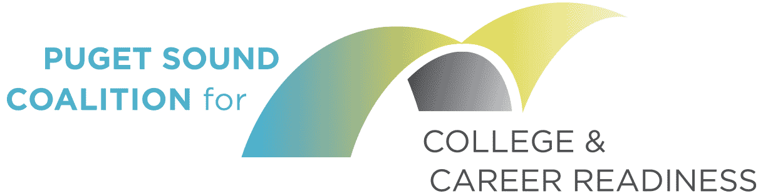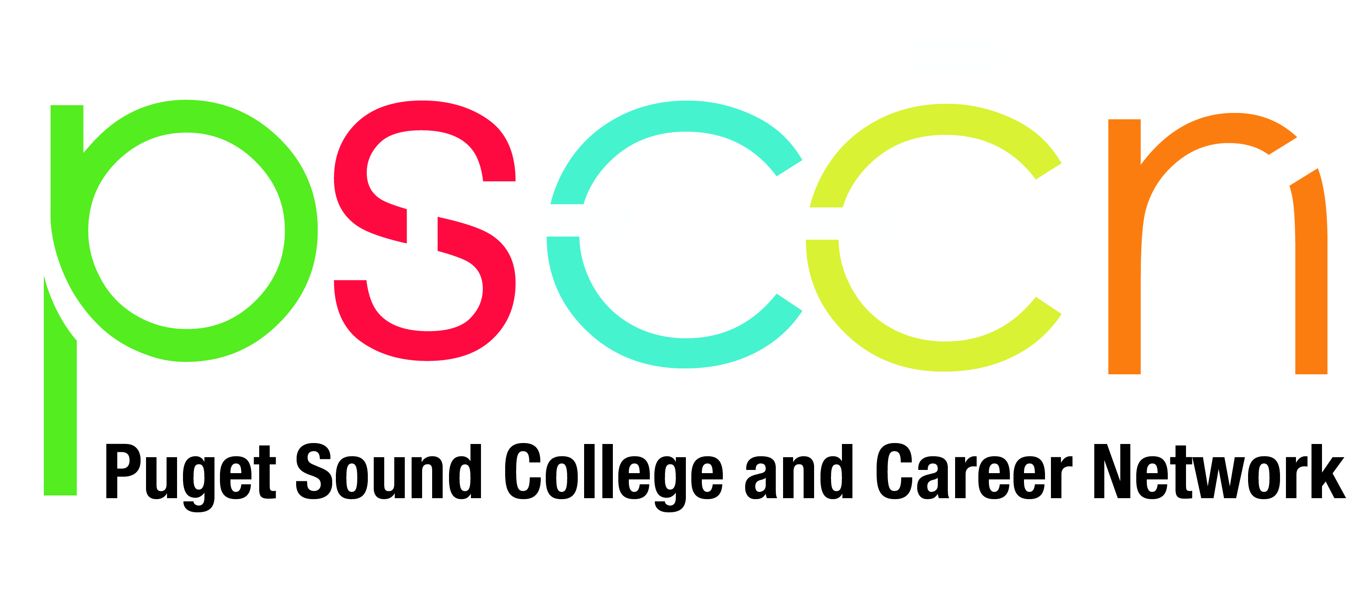

K-12: Auburn | Federal Way| Highline| Kent |Puget Sound ESD| Renton | Seattle |Tukwila
Community and Technical Colleges Bellevue| Green River| North Seattle |Renton Technical| Seattle Central| Shoreline |South Seattle
Contributing Partners University of Washington| Community Center for Education Results| Office of Superintendent of Public Instruction

MEETING AGENDA
April 6, 2018 | 8:30-10:30 AM
Puget Sound Education Service District Offices

8:15-8:30 Breakfast and Networking

I. CALL THE MEETING TO ORDER AND WELCOME NEW MEMBERS
8:30-8:45
Coalition Co-Chair Kevin McCarthy calls the meeting to order and welcomes guests

Link: 2/14/18 Coalition meeting minutes

II. PREPARATIONS FOR MAY 24 RETREAT
8:45 – 9:00

Presenters: Kevin McCarthy, Renton Technical College
Kyla Lackie and Hilary Loeb, PSESD

- Review and revise retreat goals and initial agenda
- Confirm retreat participation: May 24 from 8:30am – 12:30pm

Links: Coalition Compact
Draft Retreat Agenda

III. REGIONAL PRIORITY 3: STRENGTHENING POSTSECONDARY TRANSITION
9:00 – 9:30

Presenters: Fredolyn Millendez, PSESD
Avery, CCER

- Discuss key learning from College and Career Leadership Institute (CCLI) session on 2 year transition
- Preview of 2018-19 CCLI model and ask to districts re: August 15-16, 2018
- Feedback on new College Transition Checklists & Resource Guides

9:30 – 10:00

Presenters: Kyla Lackie, PSESD
Kevin McCarthy, Renton Technical College

- King County Promise Update & Support Needed
9:15 – 9:35

Link: Coalition Approved: King County Promise Recommendations

IV. REGIONAL PRIORITY 4: INCREASE PERSISTNCE STRATEGIES
10:00 -10:15

Presenters: Hilary Loeb, PSESD
Erin Barzen, South Seattle College

- Discuss Persistence and Completion opportunities

Link: Persistence and Completion Draft Proposal (need new link)
Persistence and Completion Presentation

V. ROAD MAP & MEMBER UPDATES
10:15 - 10:30

Presenter: Mary Jean Ryan, CCER
Coalition Members

- Share highlights from the Road Map Project 2017 Results Report

Link: 2017 Results Report

Additional Highlights:

- Save the Date: ESSA & Early Warning Event, April 20 and May 30, 2018
- South King County College & Career Policy Study and Practice: PSESD is finalizing a scan of district college and career readiness policies and practices to inform regional and local efforts.
- College Knowledge Translated Material: Student-centered digital handouts on the core components of college & career readiness are now available in Spanish, Vietnamese, Russian, Somali and English at PSCCN.org
- PSCCN Action Teams: Action Teams are meeting regularly, each focused on a specific result to leverage collective expertise, resources and to discover and model what is possible by supporting quicker small-scale work that leads to scaling of innovative strategies. Teams include:
  - Strengthening the Senior Year: Identifying resources, practices and supports to ensure all students complete high school with the knowledge and preparation to enroll in their postsecondary path.
  - Increasing Financial Aid Completion: Expanding communications, resources, and supports to ensure that more Latinx students and families apply and access financial aid for postsecondary
  - Strengthening Postsecondary Transitions: Focused on understanding and modeling solutions to address gaps in the transition process from high school to college
- Why We Drop Out: PSESD held events with local authors to share about new research and narratives stories that are both personal and important case studies of the complex factors that led some students to dropping out of school.

More details at www.psccn.org/connect

SAVE THE DATE

Retreat with Coalition & PSCCN Steering Committee May 24th from 8:30 AM-12:30 PM, Puget Sound ESD

